

SIMATS SCHOOL OF ENGINEERING
SAVEETHA INSTITUTE OF MEDICAL AND TECHNICAL SCIENCES
CHENNAI-602105

ASSESSMENT 3
CSA1006-SOFTWARE ENGINEERING

Problem 1: Full-Stack Web App Development for an E-Commerce Dashboard
SUBMITTED BY:
SRUTHI J – 192371085

Scenario

A software company is developing a full-stack e-commerce analytics dashboard. The frontend uses React, the backend uses Node.js with Express, and data is retrieved through REST APIs from a database in real time. Marketing teams require interactive charts and dashboards, while management expects fast loading, scalability, and a clean user interface. The team follows Git-based collaboration with mandatory code reviews and Continuous Integration (CI).

System Architecture

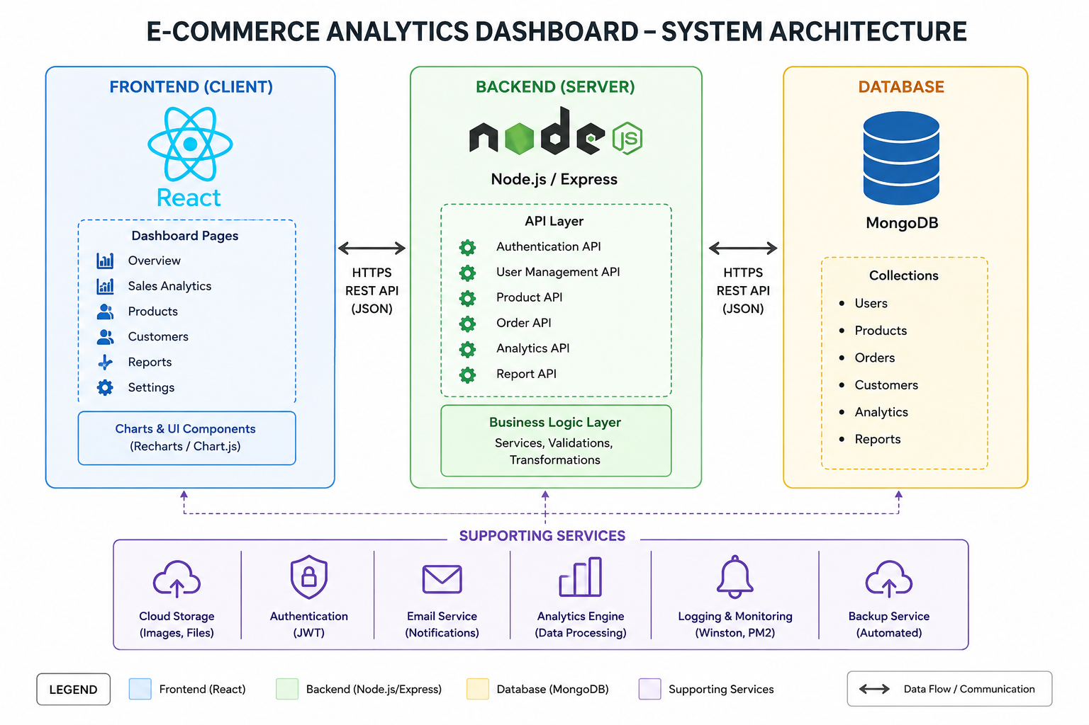

The application follows a three-tier architecture:
- React Frontend provides dashboards, charts, filters, and user interaction.
- REST API (Node.js + Express) processes requests and business logic.
- Database (MongoDB/MySQL) stores products, orders, customers, and sales.
- APIs return JSON data to the frontend in real time.
Users
│
▼
React Frontend
│
HTTP/REST API Calls
│
▼
Node.js + Express API
│
Business Logic Layer
│
▼
MongoDB / MySQL Database

2. Git Branching Strategy (Git Flow)
Branch | Purpose
main | Production-ready code
develop | Integration branch
feature/* | New feature development
release/* | Release preparation
hotfix/* | Critical production fixes
Workflow:
- Create feature branch from develop.
- Commit and push changes regularly.
- Open Pull Request into develop.
- Peer review and automated CI checks.
- Merge after approval.
- Release branch merged into main.

3. API Data Flow
1. User opens the dashboard.
2. React sends GET requests using Fetch/Axios.
3. Express receives requests and validates them.
4. Server queries the database.
5. Results are converted into JSON.
6. React updates charts and tables dynamically.

Example API Endpoints
Method | Endpoint | Purpose
GET | /api/sales | Sales analytics
GET | /api/orders | Order details
GET | /api/products | Product statistics
GET | /api/customers | Customer analytics

4. CI (Continuous Integration) Flow
- Developer pushes code to Git repository.
- CI pipeline starts automatically.
- Dependencies are installed.
- Code quality and linting checks run.
- Unit tests execute.
- Application build is generated.
- Deployment to staging if all checks pass.

5. Pull Request Review Checklist
- Code follows project coding standards.
- Feature works as expected.
- No unnecessary or duplicate code.
- API responses are validated.
- Error handling implemented.
- Security best practices followed.
- Tests added or updated.
- No merge conflicts.
- Documentation updated.

Real-World Example
Large e-commerce platforms such as Amazon, Flipkart, and Shopify rely on React-based dashboards with Node.js APIs to provide real-time sales analytics. Development teams use Git Flow, pull requests, and CI pipelines to maintain quality and accelerate software delivery.

Conclusion
A full-stack architecture separates presentation, business logic, and data storage, making the application scalable and maintainable. Git Flow improves collaboration, CI ensures code quality, and pull request reviews reduce defects before deployment. This approach enables efficient development of modern analytics dashboards.

Appendix 1
Additional Notes:
• React components communicate with backend APIs using HTTP requests.
• Express routes process business logic and interact with the database.
• Reusable components, modular services, authentication, caching, and monitoring help improve scalability and maintainability.
• Teams should follow consistent coding standards, meaningful commit messages, and regular sprint reviews to ensure successful project delivery.
Additional Notes:
• React components communicate with backend APIs using HTTP requests.
• Express routes process business logic and interact with the database.
• Reusable components, modular services, authentication, caching, and monitoring help improve scalability and maintainability.
• Teams should follow consistent coding standards, meaningful commit messages, and regular sprint reviews to ensure successful project delivery.
Additional Notes:
• React components communicate with backend APIs using HTTP requests.
• Express routes process business logic and interact with the database.
• Reusable components, modular services, authentication, caching, and monitoring help improve scalability and maintainability.
• Teams should follow consistent coding standards, meaningful commit messages, and regular sprint reviews to ensure successful project delivery.
Additional Notes:
• React components communicate with backend APIs using HTTP requests.
• Express routes process business logic and interact with the database.
• Reusable components, modular services, authentication, caching, and monitoring help improve scalability and maintainability.
• Teams should follow consistent coding standards, meaningful commit messages, and regular sprint reviews to ensure successful project delivery.

Appendix 2
Additional Notes:
• React components communicate with backend APIs using HTTP requests.
• Express routes process business logic and interact with the database.
• Reusable components, modular services, authentication, caching, and monitoring help improve scalability and maintainability.
• Teams should follow consistent coding standards, meaningful commit messages, and regular sprint reviews to ensure successful project delivery.
Additional Notes:
• React components communicate with backend APIs using HTTP requests.
• Express routes process business logic and interact with the database.
• Reusable components, modular services, authentication, caching, and monitoring help improve scalability and maintainability.
• Teams should follow consistent coding standards, meaningful commit messages, and regular sprint reviews to ensure successful project delivery.
Additional Notes:
• React components communicate with backend APIs using HTTP requests.
• Express routes process business logic and interact with the database.
• Reusable components, modular services, authentication, caching, and monitoring help improve scalability and maintainability.
• Teams should follow consistent coding standards, meaningful commit messages, and regular sprint reviews to ensure successful project delivery.
Additional Notes:
• React components communicate with backend APIs using HTTP requests.
• Express routes process business logic and interact with the database.
• Reusable components, modular services, authentication, caching, and monitoring help improve scalability and maintainability.
• Teams should follow consistent coding standards, meaningful commit messages, and regular sprint reviews to ensure successful project delivery.

Appendix 3
Additional Notes:
• React components communicate with backend APIs using HTTP requests.
• Express routes process business logic and interact with the database.
• Reusable components, modular services, authentication, caching, and monitoring help improve scalability and maintainability.
• Teams should follow consistent coding standards, meaningful commit messages, and regular sprint reviews to ensure successful project delivery.
Additional Notes:
• React components communicate with backend APIs using HTTP requests.
• Express routes process business logic and interact with the database.
• Reusable components, modular services, authentication, caching, and monitoring help improve scalability and maintainability.
• Teams should follow consistent coding standards, meaningful commit messages, and regular sprint reviews to ensure successful project delivery.
Additional Notes:
• React components communicate with backend APIs using HTTP requests.
• Express routes process business logic and interact with the database.
• Reusable components, modular services, authentication, caching, and monitoring help improve scalability and maintainability.
• Teams should follow consistent coding standards, meaningful commit messages, and regular sprint reviews to ensure successful project delivery.
Additional Notes:
• React components communicate with backend APIs using HTTP requests.
• Express routes process business logic and interact with the database.
• Reusable components, modular services, authentication, caching, and monitoring help improve scalability and maintainability.
• Teams should follow consistent coding standards, meaningful commit messages, and regular sprint reviews to ensure successful project delivery.

